WIDA ASSESSMENTS TEST PRACTICE AND SAMPLE ITEMS
Families have access to a test demo, sample test items and practice tests provided by WIDA:
- The Test Demo is a series of videos that explain how students will take the online test and interact with the test platform.
- The Sample Items provide students, parents, and educators with a better understanding of the ACCESS for ELLs Online. These are not items that will appear on the operational test, but they are similar.
- The Test Practice items are designed to allow students to experience taking the assessment online and to experiment with the features available to them during testing. The above link provides access to the Test Practice items for ACCESS for ELLs Online and WIDA Screener Online.
To access and view the Test Practice Items, a Chrome browser must be used if you are on Windows, macOS, ChromeOS, or Linux Devices. If you are on an iPad, you must use the Safari Browser
The practice test link, above, allows access to practice for the Screener and ACCESS, sample items and test demo:
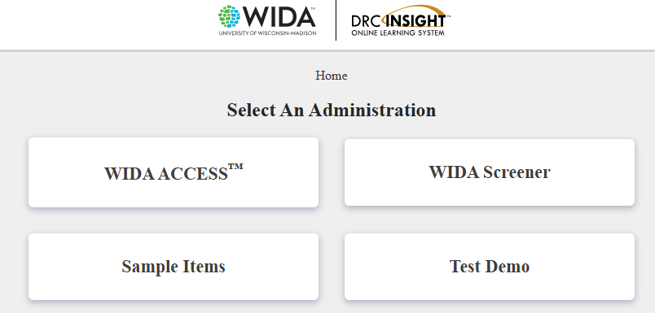

Click on WIDA ACCESS or WIDA Screener and select a domain to get started:
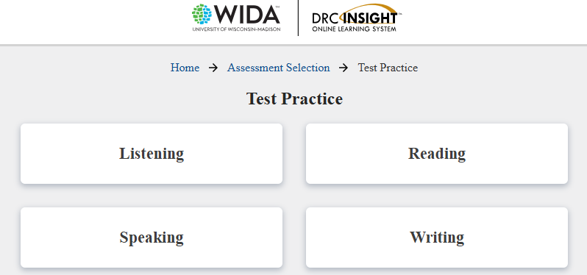

Select grade level. Kindergarten students can select Grade 1:
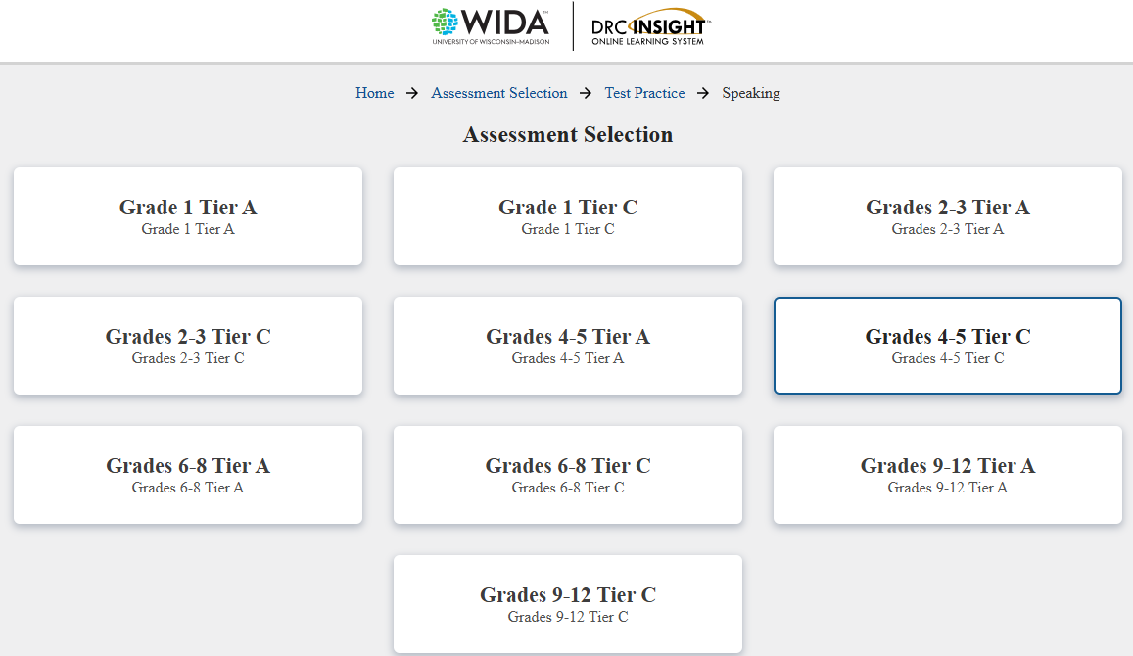
Follow the prompts from there.
Do the same for Sample Items and Test Demo.

